LAB EXPERIMENT
SET 25: WEBSITE TRAFFIC ANALYSIS

Department | AIDS
Course Code / Course Name | DSA0602 / Data Handling and Visualization
Experiment | Data Visualization using R and Tableau
Name | D.HEMASREE
Register Number | 192524114
Date | 20 October 2026
Day | Tuesday

Aim
To analyze website traffic data using a line chart in Tableau, a bar chart and a stacked area chart in R, and to build an interactive dashboard with a map and a bar chart using Tableau. Dataset: Website Traffic

Date | Page Views | Click-through Rate
2023-01-01 | 1500 | 2.3%
2023-01-02 | 1600 | 2.7%
2023-01-03 | 1400 | 2.0%
2023-01-04 | 1650 | 2.4%
2023-01-05 | 1800 | 2.6%
Note: the question gives no data for user interactions (likes, shares, comments) or traffic sources. Sample values are assumed for Program 3 and Program 4 and shown in those programs. Replace them with your own figures if your faculty has provided them.

PROGRAM 1: Line Chart of Page Views Over Time (Tableau)
In Tableau, create a line chart to visualize the trend in page views over time. Label the axes and title the chart.

Steps in Tableau
- Save the data as an Excel or CSV file and connect to it in Tableau (Connect > Microsoft Excel / Text file). Make sure Date is set as a Date data type.
- Drag Date to Columns and choose Day (continuous) from its drop-down. Drag Page Views to Rows (SUM).
- Set the Marks type to Line, drag Page Views to Label, and add circle markers from the Color/Marker options.
- Label the axes by right-clicking each axis > Edit Axis > Title: "Date" and "Page Views". Double-click the sheet title and enter "Trend in Page Views Over Time".

OUTPUT:
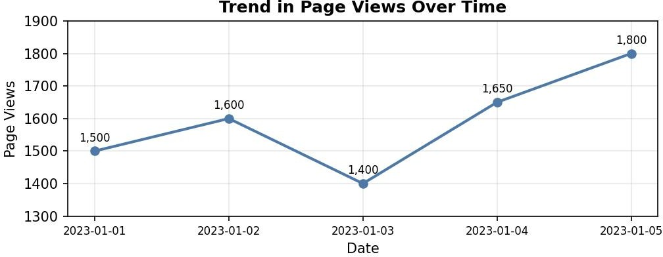
Output 1: Trend in Page Views Over Time (Tableau Line Chart)

Observation:
Page views start at 1,500 on 1 January and rise to 1,600 on 2 January. They then fall to the lowest value of 1,400 on 3 January (about 12.5% down), before recovering to 1,650 on 4 January (+17.9%) and reaching the highest value of 1,800 on 5 January (+9.1%). Overall, page views grew by 20% over the five days.

PROGRAM 2: Bar Chart of Top N Days by Click-through Rate
In R, generate a bar chart to show the top N days with the highest click-through rates. Label the chart elements.
# Dataset
traffic <- data.frame(
Date
= as.Date(c("2023-01-01", "2023-01-02", "2023-01-03",
"2023-01-04", "2023-01-05")),
Page_Views = c(1500, 1600, 1400, 1650, 1800),
CTR = c(2.3, 2.7, 2.0, 2.4, 2.6)
)

# Top N days with the highest click-through rate N <- 3
top_n <- head(traffic[order(-traffic$CTR), ], N)

# Bar Chart barplot(top_n$CTR,
names.arg = format(top_n$Date, "%Y-%m-%d"),
col = c("steelblue", "darkorange", "forestgreen"), xlab = "Date",
ylab = "Click-through Rate (%)",
main = "Top 3 Days by Click-through Rate", ylim = c(0, 3.5))

OUTPUT:
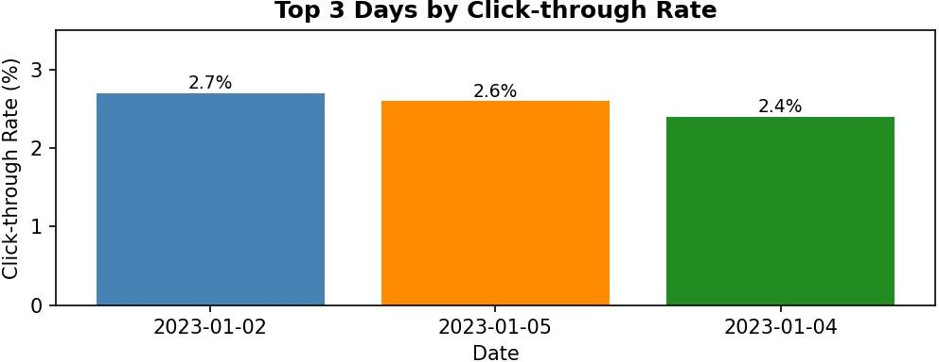

Output 2: Top 3 Days by Click-through Rate (Bar Chart)

Observation:
With N = 3, the top days are 2 January (2.7%), 5 January (2.6%) and 4 January (2.4%). The lowest click-through rate (2.0%) fell on 3 January, the same day as the lowest page views, and the average rate over the five days is 2.4%. The highest rate was not on the day with the most page views, so more views do not always mean a higher click-through rate.

PROGRAM 3: Stacked Area Chart of User Interactions
In R, build a stacked area chart to display the distribution of user interactions (likes, shares, comments) on the website.

Dataset (user interactions are assumed):

Date | Likes | Shares | Comments | Total
2023-01-01 | 120 | 45 | 25 | 190

Date | Likes | Shares | Comments | Total
2023-01-02 | 150 | 60 | 30 | 240
2023-01-03 | 110 | 40 | 20 | 170
2023-01-04 | 170 | 65 | 35 | 270
2023-01-05 | 190 | 80 | 45 | 315
Total | 740 | 290 | 155 | 1185
library(ggplot2)

# Dataset in long format (likes, shares and comments are assumed values) dates <- as.Date(c("2023-01-01", "2023-01-02", "2023-01-03",
"2023-01-04", "2023-01-05"))
interactions <- data.frame(
Date = rep(dates, times = 3),
Interaction = rep(c("Likes", "Shares", "Comments"), each = 5), Count = c(120, 150, 110, 170, 190,
45, 60, 40, 65, 80,
25, 30, 20, 35, 45)
)

# Stacked Area Chart
ggplot(interactions, aes(x = Date, y = Count, fill = Interaction)) + geom_area() +
labs(title = "Distribution of User Interactions", x = "Date",
y = "Number of Interactions", fill = "Interaction")

OUTPUT:
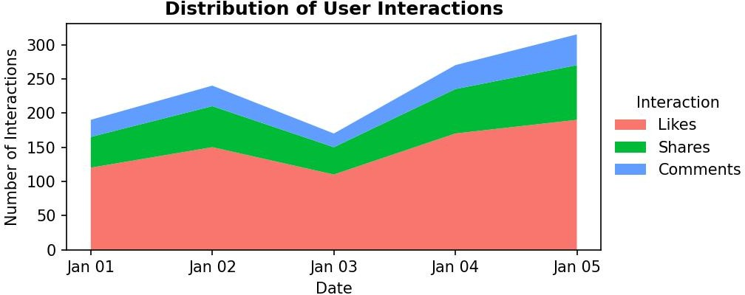
Output 3: Distribution of User Interactions (Stacked Area Chart)

Observation:
Total interactions rise from 190 on 1 January to a peak of 315 on 5 January, with a dip to 170 on 3 January that matches the dip in page views. Likes form the largest layer, about 62.4% of the 1,185 total interactions, followed by shares (about 24.5%) and comments (about 13.1%).

PROGRAM 4: Tableau Dashboard with Map of Traffic Sources and Page Views by Source
In Tableau, create a dashboard with an interactive map showing traffic sources and a bar chart displaying page views by source.

Dataset (traffic sources are assumed; both tables add up to the 7,950 total page views):

Source | Page Views | Share
Organic Search | 3200 | 40.3%
Direct | 1800 | 22.6%
Social Media | 1500 | 18.9%

Source | Page Views | Share
Referral | 950 | 11.9%
Email | 500 | 6.3%
Total | 7950 | 100%

Country | Page Views | Share
India | 3100 | 39.0%
United States | 2000 | 25.2%
United Kingdom | 1100 | 13.8%
Germany | 900 | 11.3%
Australia | 850 | 10.7%
Total | 7950 | 100%

Steps in Tableau
- Prepare a traffic source file with the columns Source, Country and Page Views and connect to it in Tableau.
- Sheet 1 (Map): Double-click Country so Tableau creates Latitude and Longitude. Drag Page Views to Size and to Color, and set the Marks type to Map (or Filled Map). Add Country and Page Views to Tooltip. Rename the sheet "Traffic Map".
- Sheet 2 (Bar Chart): Drag Source to Rows and Page Views to Columns (SUM). Sort in descending order, add Page Views to Label and rename the sheet "Page Views by Source".
- Create a new Dashboard (Dashboard > New Dashboard), set the size to Automatic, and drag the "Traffic Map" and "Page Views by Source" sheets onto the dashboard area.
- Add interactivity: select each view and click Use as Filter, so clicking a country on the map filters the bar chart (and a bar filters the map). Add a Source filter (Show Filter > Apply to Worksheets > All Using This Data Source).
- Add the title "Website Traffic Dashboard" and test the filters in Presentation Mode.

OUTPUT:
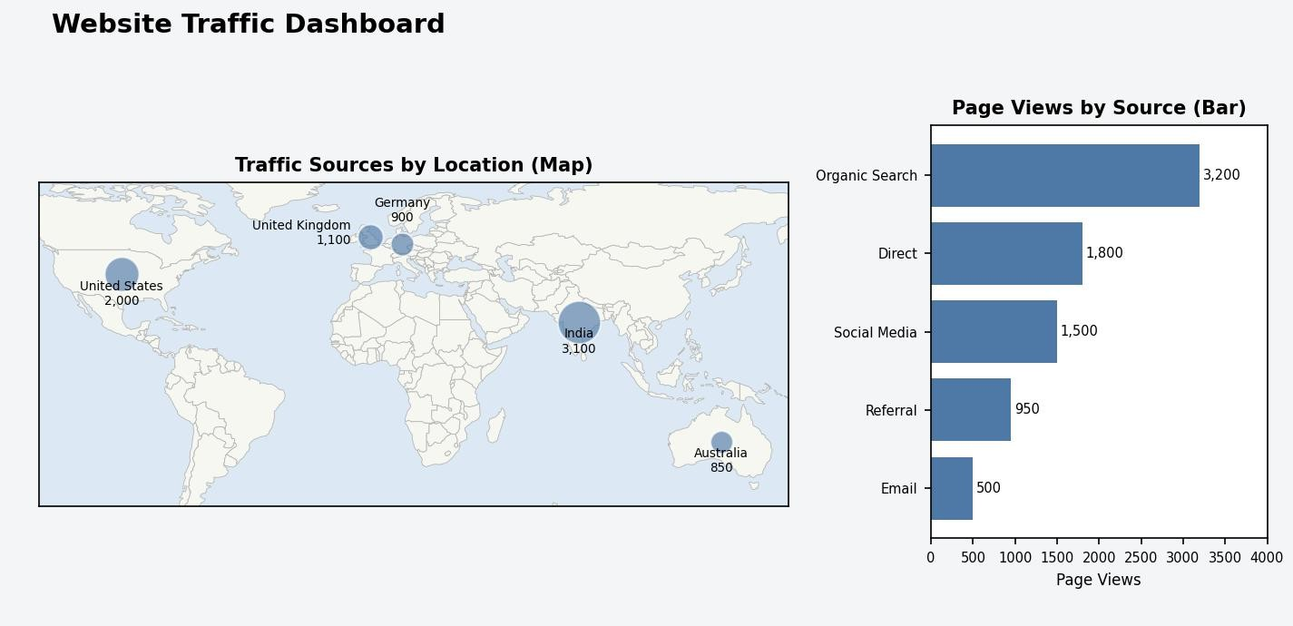
Output 4: Website Traffic Dashboard (Tableau)

Observation:
The dashboard shows where the traffic comes from and which sources bring the most page views. Organic Search is the largest source (3,200 views, about 40.3%), followed by Direct (1,800) and Social Media (1,500), while Email is the smallest (500). On the map, India (3,100) and the United States (2,000) are the largest locations. Clicking a country on the map filters the bar chart to that country's sources.

Procedure
- Load the website traffic data into Tableau, set Date as a Date field and build the line chart of page views.
- Create the traffic data frame in R, sort by click-through rate with order() and use barplot() to draw the top N days.
- Arrange the interaction data in long format and use ggplot2 with geom_area() to draw the stacked area chart.
- Load the traffic source data into Tableau and build the map and the bar chart worksheets.
- Combine the worksheets in a Tableau dashboard and add filters and actions for interactivity.

RESULT:
The website traffic data was successfully analyzed using a line chart in Tableau and a bar chart and a stacked area chart in R. An interactive Tableau dashboard was also created, combining a map of traffic sources and a bar chart of page views by source so that users can explore the traffic by location and by source.

Key Functions and Tools Used

Function / Tool | Purpose
data.frame() / as.Date() | Creates the traffic table with proper dates.
order() / head() | Finds the top N days by click-through rate.
barplot() | Creates the bar chart of top N days.
ggplot() / geom_area() | Creates the stacked area chart of interactions.
Tableau Line / Map marks | Builds the page views line chart and the traffic map.
Tableau Dashboard | Combines worksheets with filters and actions.

